Why use Quizlet | NEEDS FIXING
Accessing Quizlet | 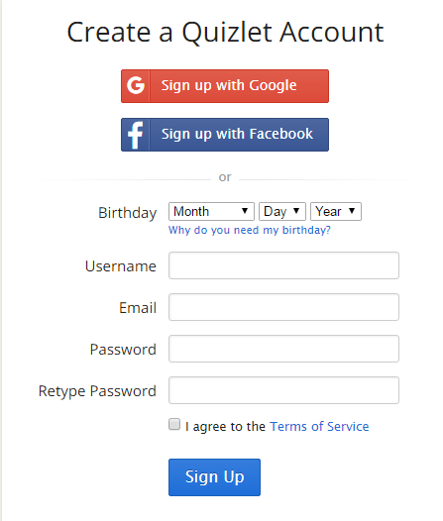  https://quizlet.com  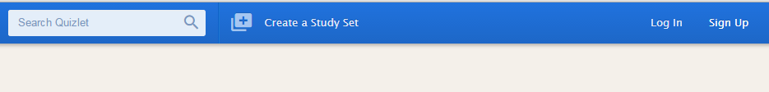  Quizlet is free. Create an account.
What the  Student Sees | 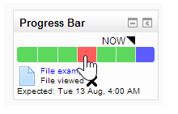  Green- activity is complete; Red- activity is overdue; Blue- activity is not completed but not due yet.  When the mouse hovers over the individual blocks, the activity description is displayed with the due date.  A student may press on the box to link them directly to the activity.
The Overview Page | 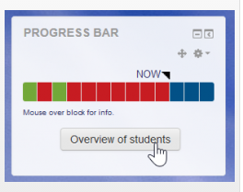  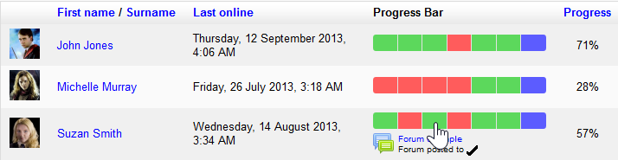  There is an overview page allowing teachers to see the progress of all students in a class, which is helpful for finding students at risk.  If you want to send an email from this overview page, simply check on the students’ name.

Adding a  Progress Bar | 1. To add a new Progress Bar block  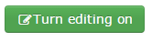  2. Add a Block: Progress Bar  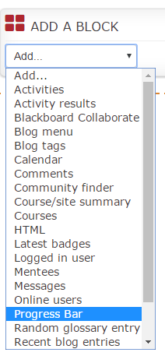  3. Select Settings:  - If you would like to change the title of the Progress Bar as it appears on the Course page for both instructors and students, type the new title into the Alternate title box. Otherwise, the block will have the title Progress Bar.  - In the Use icons in bar drop-down list, select yes if you would like the check mark and "x" symbols to appear in each slot of the progress bar to show if an activity is completed or not. These symbols will display in black as illustrated below.  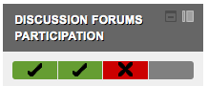  - Select the sequence in which you would like the tracked items to appear on the bar from the Order bar items by drop-down list. You can select either "Expected by" date-time, which can be configured for each individual activity or resource (as documented below in the Monitored  - activities/resources section), or Ordering in a course, which sequences them in the order they appear on the main course page.  Select Activities/Resources  Choose to:  Monitor all activities (pre-fills configuration page)  Select activities to monitor (start from scratch)  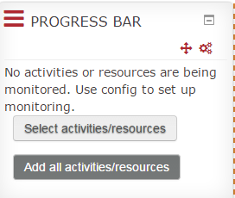 | 4. Select Activities/Resources  Choose to:  Monitor all activities (pre-fills configuration page)  Select activities to monitor (start from scratch)    5. Check ‘Yes’ for each item you want to monitor with the Progress Bar.  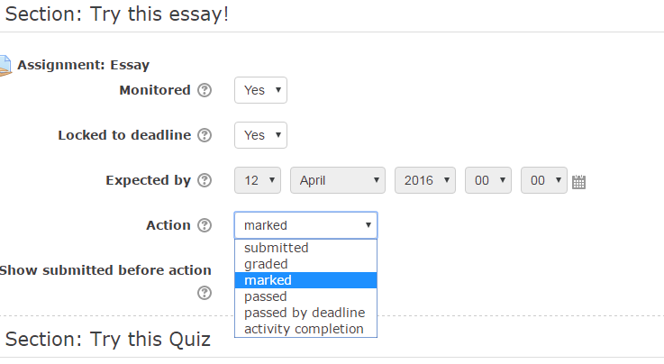  5  6  6. If you had a date for this activity it will be displayed. Otherwise, decide if you want to  lock the activity to the deadline.  7. Decide how the activity will be monitored.  8. Save changes.  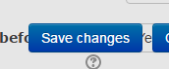
Other Points to Remember | Hidden items will not appear in the Progress Bar until they are unhidden.  This is useful for a scheduled release of activities.
For a more detailed description of ……..
https://moodle.org/plugins/view.php?plugin=block_progress

